Learning-Based On-Track System Identification for Scaled autonomous racing under minute

(Reproducing and conclusion)

introduction
This paper uses a simple steps for identifying the tire pacjika model parameters
To identifying those parameter the following steps is being followed:
- Collect a dataset online while the car is moving using a model free controller such as pure-pursuit, the dataset collected contain the following .
- The data collection procedure last for 30 second, after that the data is then passed to the neural network to predict the error of the current reading and next reading from the dataset.
  - Neural network parameters [4 input layer , 8 neurons in hidden layer, 2 output layer].
  - The activation function for the hidden layer is leaky relu to introduce non-linearity.
- After the training finished a synthetic data is generated in the steady state with following condition:
  - is constant , and the steering is increasing linearly. The output is corrected from perviously modeled error network.
  - The steady state required to make the below equation valid
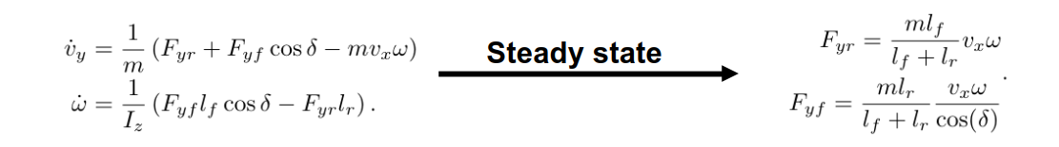
  - after the steady state data is generated; the pacjika tire is then estimated using linear least square regression.

Experiment design
The experiment used the f1tenth low fidelity simulator as stated int the following figure that
use simple mathematical models to simulate the car behaviors, and used RVIZ (ROS Visualization) as visualization tool.
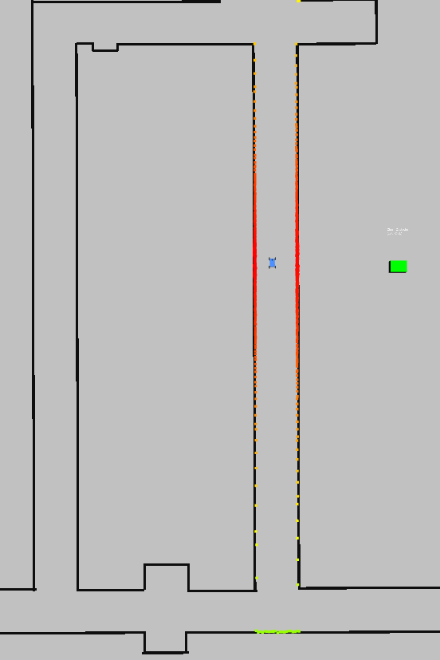Figure 1: simulator used
The provided parameter for the simulator is the mass, inertia, and the
vehicle dimension.

Multiple given path scenarios is give to test the approach in two main scenarios , to test if the approach need to excite the v_{y} and to give good result or not:
- Zigzag path
- Smooth straight path
Not only the path is change, but also the neural network’s parameters , linear velocity is changed to test the performance, and if the approach is pruned to over-fit quickly.
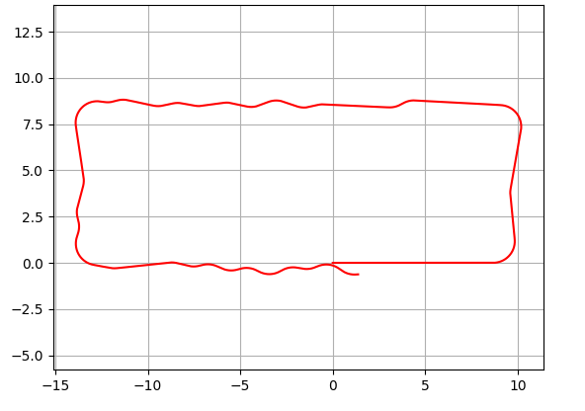Figure 2: Zigzag path
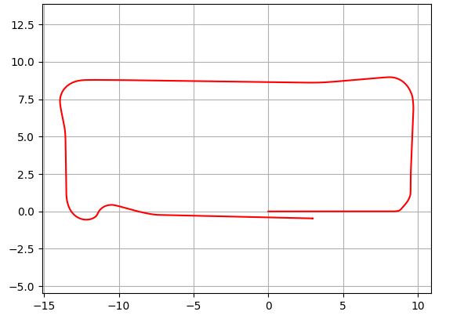Figure 3: smooth path

